Meeting with Yaz Abutaleb
Head of Customer Operations
2026-04-06
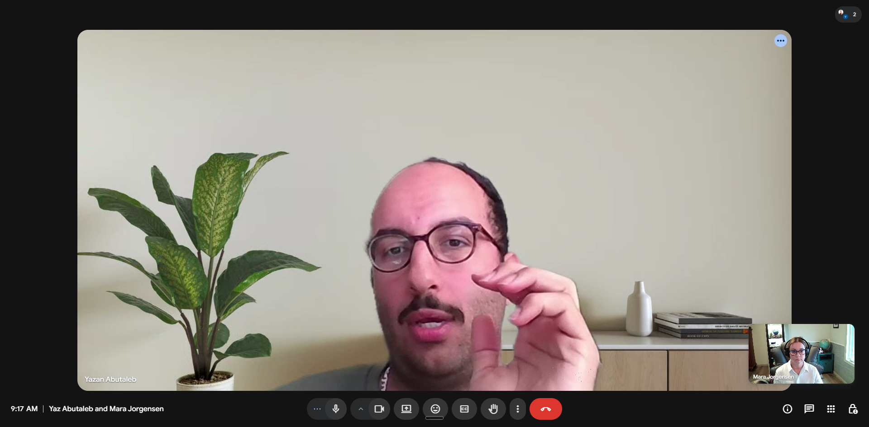
Prep
- https://www.linkedin.com/in/yazan-abutaleb-2018/
- Questions
  - How do you conduct customer discovery?
  - What is your sales pitch?
  - Why agriculture?
  - What does the hand off look like at or after implementation?
    - I often notice a lack of communication/coordination between Custoemr Ops and engineering, like to hear how that goes at SWARM
- We have a lot in common
  - Enterprise apps
  - Love interfacing with customers
  - Love solving problems
- Notes from Claude
  - SWARM Engineering: Core Business Summary
  - SWARM is a decision intelligence platform for agriculture, food, and industrial supply chains. Two products:
  - ENGINE: optimization backbone that models across thousands of variables (production, labor, logistics, inventory). Think operations research/mathematical optimization.
  - AVA: agentic AI layer trained on ag ontology for natural language Q&A across disconnected data sources.
  - They're merging these into a unified platform this quarter. Key customers: Cargill, Ardent Mills (43 mills, 110M variables), Agrovision (workforce planning in Peru), Wilbur Ellis, AFCO, Google. ~10 paying customers, $1.8M ARR. Engineering team in Romania, leadership in the US. Shail (CEO) came from CMO/CCO roles at Blue Prism, UiPath, Automation Anywhere.

  - 20 Questions for Yaz Abutaleb (Head of Customer Success)
  - Given your shared background in customer success, these are designed to go deep on ICP, GTM, CS operations, and give you signal on the maturity and health of the business.
  - ICP and Market
  - How does SWARM define its ideal customer profile today, and has that changed since you joined?
  - What's the typical entry point for a new customer: do they come in through ENGINE, AVA, or a specific use case like workforce planning or logistics optimization?
  - What's the minimum company size or operational complexity where SWARM's value prop really clicks? Is there a threshold below which it doesn't make sense?
  - Of the ~10 current customers, how would you segment them: are most ag, food, industrial, or something else? Where do you see the most pull?
  - How much of the pipeline today comes from Shail's personal network versus inbound versus outbound sales motion?
  - Customer Acquisition and GTM
  - What does the sales cycle look like from first conversation to signed contract, and how long does it typically take? How do you see the CPO helping with this?
  - Who is the economic buyer in these deals: is it a COO, VP of Supply Chain, CTO, or someone else?
  - How are you positioning against what these companies already have in place, whether that's ERP add-ons, homegrown spreadsheet models, or competitors like o9 Solutions or Kinaxis?
  - What role does customer success play in the sales process today? Are you involved pre-sale, or only post-close?
  - Is the GTM motion today more land-and-expand within existing accounts, or primarily focused on net-new logos?
  - Customer Success Operations
  - What does onboarding look like for a new customer? You mentioned "weeks not months" on the website. Is that accurate in practice?
  - How do you measure customer health today? Is there a formal health score, or is it more relationship-driven at this stage?
  - What does your CS team look like right now in terms of headcount and structure, and where are you planning to grow it?
  - What's the biggest reason a customer engagement stalls or underperforms after go-live?
  - How do you handle the feedback loop from customers back into product? Is there a formal process, or is it more ad hoc given the team size?
  - Product and Expansion
  - When a customer starts with one use case (say, logistics optimization), how do you identify and drive expansion into additional workflows?
  - With ENGINE and AVA merging into a unified platform this quarter, how are existing customers reacting to that transition?
  - How much of the current value delivery depends on SWARM's professional services or data science team versus self-service adoption by the customer?
  - Culture and Role Insight
  - What surprised you most about SWARM after joining, either positively or as a challenge you didn't expect?
  - With the company at $1.8M ARR and ~10 customers, what does Shail see as the biggest bottleneck to getting to the next stage of growth: is it product, GTM, talent, or something else?

Notes
- Yaz – pronounced like a “ah”
- GTM pre-and post sales
- Employee #14 of 15
- SaaS product
  - ENGINE In current iteration – it is not scalable today
    - Require them limiting potential
- Ramp up time
  - The thing that requires the alignment of the data schema for each customer
  - Quite a biof time for each customer
  - Each customers unique use case or niche
  - Gap from too SaaS
  - Factilitate an OOB solution
- Customer success
  - Pre-sales is an 8 week ramp up
  - Make sure schemas are completely formatted
  - Ideally can birgn that doen to 4 weeks
  - He wants to enable for them to use the product for them to ramp up
Granola Notes
Swarm — Company & Product Overview
- ~15-person startup, recently closed an oversubscribed Series A
- Series B fundraise expected later this year; growth-oriented, though open to acquisition if the right offer came in
- Culture: fast-paced, collaborative, direct — people push back openly but align quickly
- Benefits: full healthcare, 401k, unlimited PTO (in practice, proactive planning required)
- Leadership: Shail (CEO, joined ~6 months before Yaz), Joe (CTO, currently owns product), Paul (SVP Data Science, currently on leave)
Product & Core Challenge
- Two products: Engine (core AI/data product) and Ava (AI layer on top)
- Not purely SaaS — each customer requires bespoke data schema mapping before going live
  - Current onboarding: ~8 weeks; target with better tooling: ~4 weeks
  - The bottleneck is understanding and aligning each customer’s data structure, which can’t easily be compressed
- Open question: build vs. buy for ETL/middleware/data integration layer to reduce implementation burden
  - Yaz sees opportunity to develop a standardized “Swarm framework” that could be configured per customer niche
- Product positioning is unclear — hard to tell what use cases/verticals Swarm is targeting
  - Mara flagged this as a likely source of customer confusion and a priority to resolve
Product–Customer Success Alignment
- Yaz’s observation: product updates currently have to be pulled from the team; no proactive demo cadence
- Yaz is building a Customer Advisory Board (CAB) to create a direct feedback loop between customers and product
- Mara’s suggested approach:
  - Regular product demo cadence (e.g., every Tuesday) with engineers demoing their own features
  - Weekly status report to execs covering product delivery, customer health, and risk — especially in the first 90 days
  - Customer ops leader included in agile ceremonies and on the product roadmap
- Both aligned: product and customer ops should sync daily, not just in formal meetings
Next Steps
- Mara Jorgensen
  - Email Shail to request the investor/pitch deck (offer to sign NDA already made)
  - Watch for intro email from Shail (expected end of day today or tomorrow morning)
- Shail
  - Send Mara the investor deck and pitch deck
  - Intro Mara to Joe (CTO) for a product demo and deeper product conversation

Chat with meeting transcript: https://notes.granola.ai/t/b839b371-4977-4b8b-9c10-1dfe983e2b62

